Demonstrate the working of execution context when calling a function addNumbers().

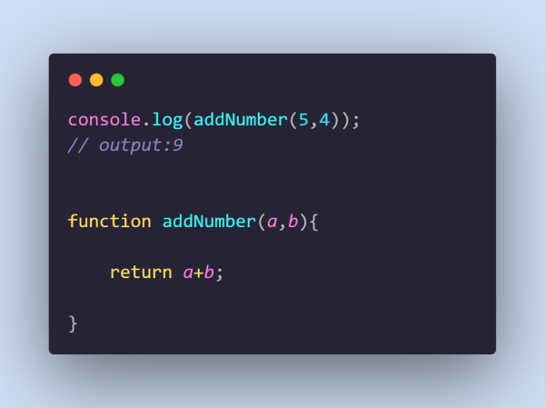

At line1, when console.log(function name) is treated as a function call. In a global execution context, the function is copied, but all values are assigned undefined. When the code execution starts in that part local execution context is created and values are assigned in the variable. Operations are done in that part to return the value.

In callstack, when the program snippet is running G.E.C is created and pushed in the stack. When the function is called then another local execution context is created and stacked upon the G.E.C. After completion of the operation of the function, L.E.C is removed and also after completion of the main program, the G.E.C also vanished.

